Step 1 — Launch EC2 Instance:
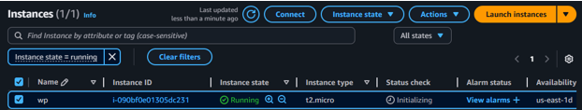
Then SSH into server:
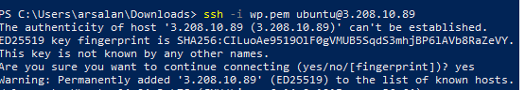
Step 2 — Update and install dependencies:
Install apache:
Install Python and pip:
Install uWSGI:

Step 3 — Create a Python web app:
- Create a project folder
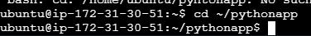
- Create a virtual environment:

- Install Flask:
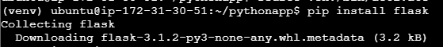
- Create app.py:
Inside the nano file write this:
(note): Port 5000 is the default port Flask uses for its development server. 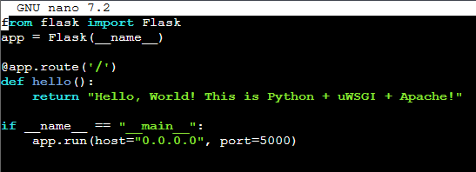

(Note): Allow port 5000 in your EC2 security group:
- Go to your AWS Console → EC2 → Security Groups.
- Select the security group attached to your instance.
- Inbound rules → Edit → Add rule:
  - Type: Custom TCP
  - Port: 5000
  - Source: 0.0.0.0/0 .
- Save rules.
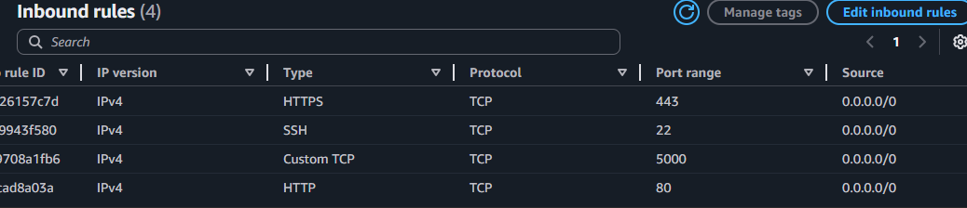

Step 4 — Test locally (optional):
- Visit http://<EC2public-IP>:5000
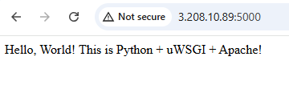

Step 5 — Configure uWSGI:
- Create app.ini in the project folder:
- Inside nano file write this:
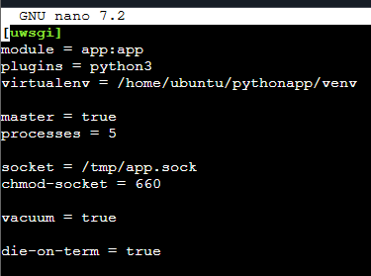

- Test uWSGI:
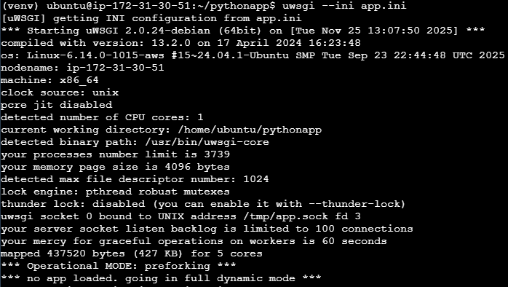

Step 6 — Configure Apache with mod_proxy_uwsgi:
- Enable required Apache modules:
- Create Apache site configuration:

Add:
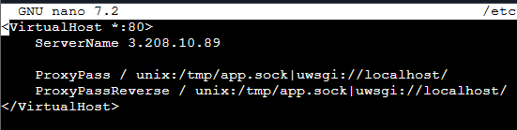
- Enable the site and reload Apache:
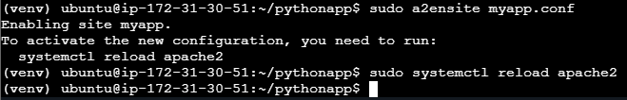

Step 7 — Start uWSGI as a background service:
Create a systemd service for uWSGI so it runs automatically:
ADD:
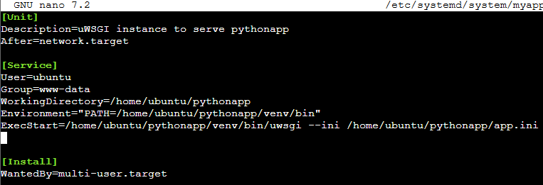
Enable and start it:

NOTE : Add to Install uWSGI inside venv (recommended)
- Activate venv:
- Install uWSGI inside venv:
- Confirm:

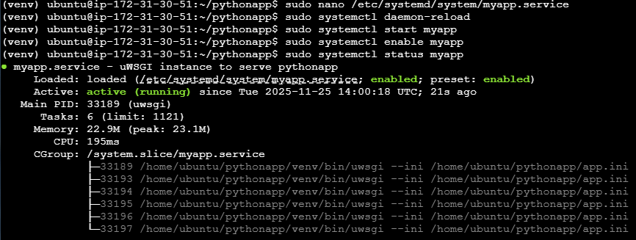

Step 8 — Open browser:
